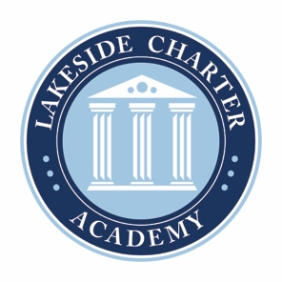
Lakeside Charter Academy, in partnership with parents, will cultivate engaged learners through scholarship, leadership, and citizenship
Agenda: Lakeside Charter Academy
Regular Meeting
Board of Directors Meeting

Location: Conference Call
712.451.0432; 555810

September 23, 2021 | 7PM EST

- Call to Order
- Reading of Conflict of Interest Statement
- Approval of August 26, 2021, Minutes*
- Reports – Principal report,Enrollment update, handbooks and policy changes, enrollment/marketing, activities/Friday Forums, parent surveys, PAT, online education, iReady, academic update, contingency plan, etc.
- Charter Renewal Update – Jim and Susanne
- Finance – Business manager
  - Review Statements
  - Staffing approval and updates – approval of contracts being issued*
  - Audit Update
  - River Church Lease*
  - Mask Policy*
  - Health Wellness Policy*

- Adjourn

* Requires Board Action

