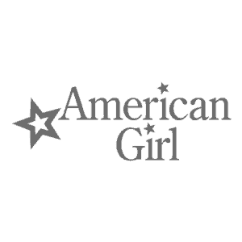
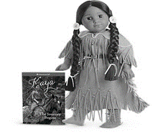

American Girl Doll Club

Please Join Mrs. Gudmestad and Mrs. Bailey for American Girl Doll Club. We will be learning all about the doll Kaya. Kaya is a young active Native American girl from the Nez Perce tribe of the 1700’s. Students will have the opportunity to listen to stories and create weekly crafts. We hope you will join us in celebrating Kaya’s life.

This club will be on Monday’s from 3:15-4:15 the cost will be $160
This is a six week program and will run from March 2nd –April 6th

Please fill out the below portion and return
with cash or check made payable to LCA

Student Name: ______________________________________
Student Grade: _____________
Parent’s Name: _______________________________________
Parent’s phone # ____________________________

